d i g i t a l c o p i e r
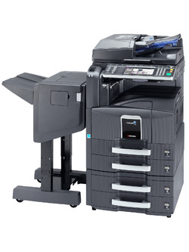

Digital Copier CS-420i

CS-420i Digital Copier
DP-760 Dual Scan Document Processor
Standard 2GB RAM and 160GB HDD
1000 Sheet Finisher
Auto Duplexing Copy
2 x 500 Cassette, 1 x 250 Multi-pass
3000 Sheet Paper Deck
Setup & Delivery

$175.00/mo. (for 5 years lease) Special Introductory Price
- Short Vertical Paper Path  - Re-try Paper Feed System  - Quick 4.8 sec. First Copy  - 25% to 400% Zoom  - Standard Electronic Sort  - Page Numbering  and lot more of digital effects… | - 600 dpi Color Scan, Copy, Print or Fax  - Super G3 Fax, 12MB Memory  - Scan/Print- 42 PPM Letter Size  - Network- Windows, Novell, Macintosh  - PCL 6, PS 3, KCGL Compatible  - 10/100BaseTX, IEEE 1284, USB 2  - Shared Copy/Scan, Print memory
($14125.00)



Other Options
Paper Deck(3000 Sheet)
Finisher (Staple, Hole Puncher, Folding)
Network Fax System

Tel: (818) 779-2828 Fax: (818) 779-2827 www.mycopy.com

OFFICE LAND

